https://vm-gitlab01.tcsbank.ru/infra-compute/repository/repository
20210210 Stash repository names as repository.docx

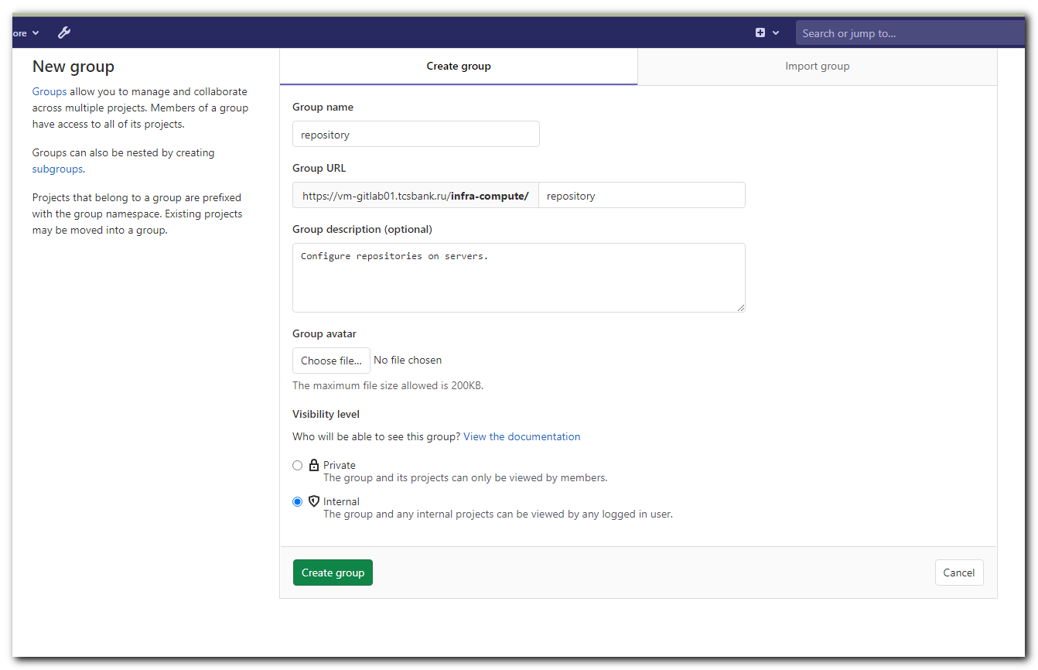
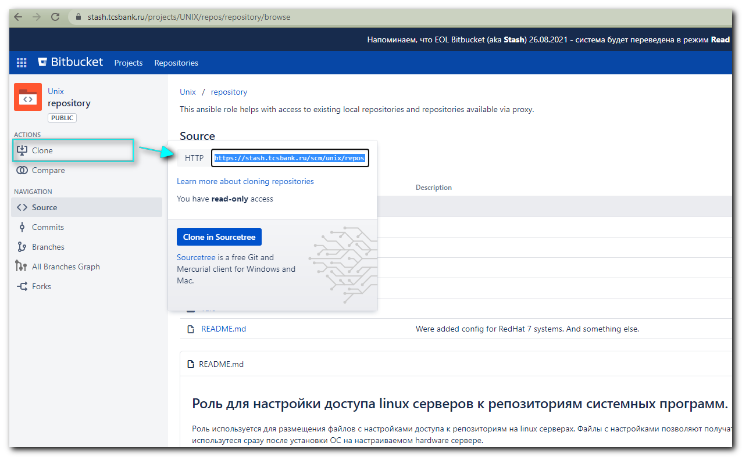
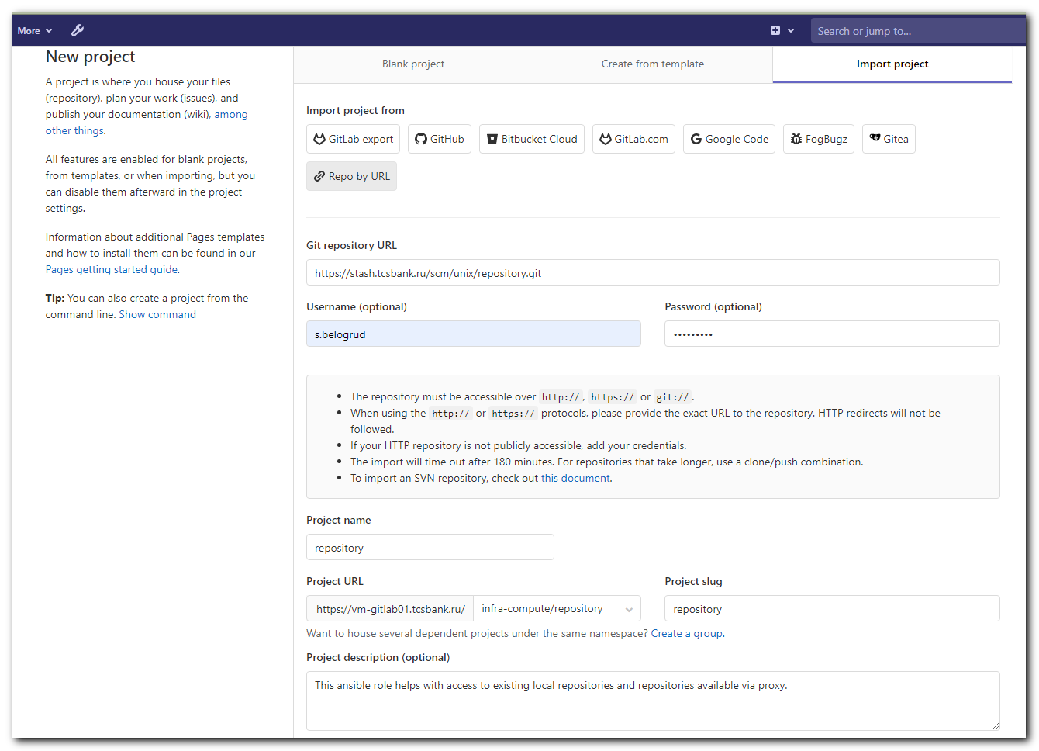
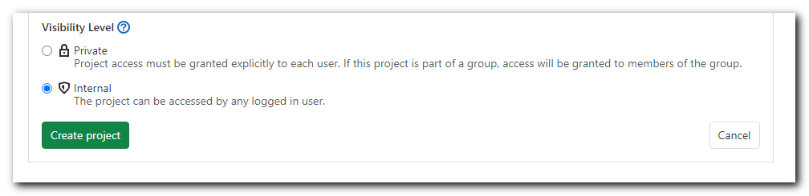
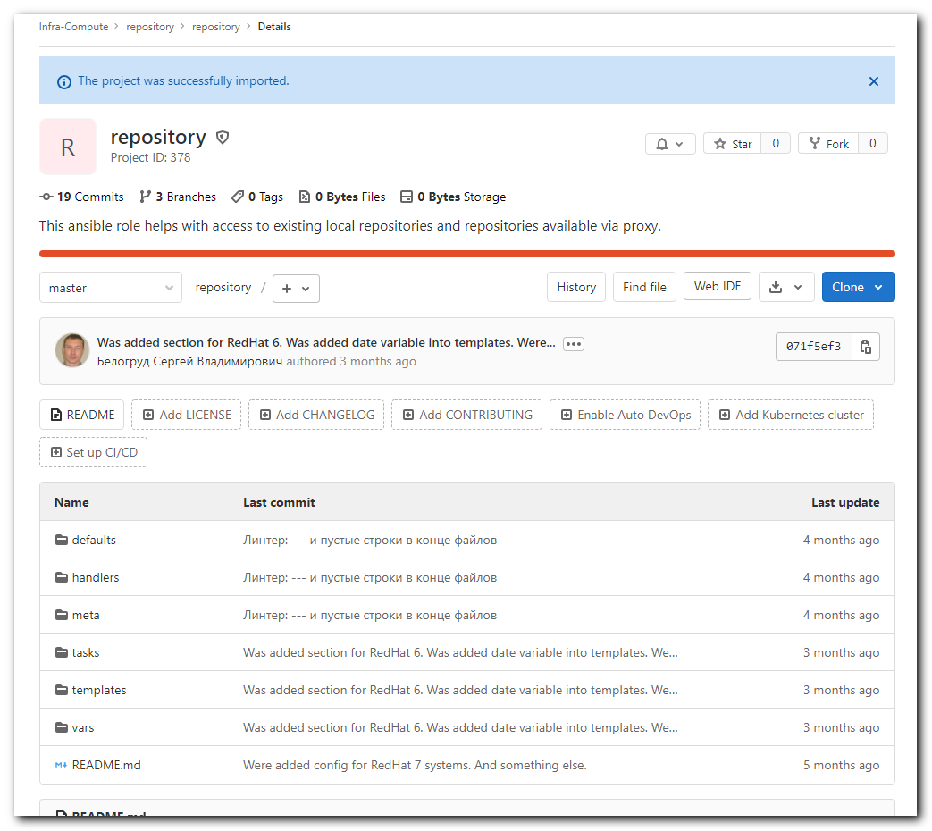

[s.belogrud@nb2339]# git clone -c http.sslVerify=false https://vm-gitlab01.tcsbank.ru/infra-compute/repository/repository.git
Клонирование в «repository»…
Username for 'https://vm-gitlab01.tcsbank.ru':
Password for 'https://s.belogrud@vm-gitlab01.tcsbank.ru':
remote: Enumerating objects: 296, done.
remote: Counting objects: 100% (296/296), done.
remote: Compressing objects: 100% (92/92), done.
remote: Total 296 (delta 83), reused 296 (delta 83), pack-reused 0
Получение объектов: 100% (296/296), 37.50 KiB | 169.00 KiB/s, готово.
Определение изменений: 100% (83/83), готово.
[s.belogrud@nb2339]#

[s.belogrud@nb2339]# cp -r repository/* ./
[s.belogrud@nb2339]# cp -r repository/.git* ./
[s.belogrud@nb2339]# rm -rf repository/

[s.belogrud@nb2339]# vim .git/config
[s.belogrud@nb2339]# cat .git/config
[core]
repositoryformatversion = 0
filemode = true
bare = false
logallrefupdates = true
ignorecase = true
[http]
sslverify = false
[remote "origin"]
url = ssh://git@vm-gitlab01.tcsbank.ru:22/infra-compute/repository/repository.git
# url = https://vm-gitlab01.tcsbank.ru/infra-compute/repository/repository.git
fetch = +refs/heads/*:refs/remotes/origin/*
[branch "master"]
remote = origin
merge = refs/heads/master
[ssh]
identity = /home/mobaxterm/.ssh/id_rsa_s.belogrud

[s.belogrud@nb2339]# git status
На ветке master
Ваша ветка обновлена в соответствии с «origin/master».

нечего коммитить, нет изменений в рабочем каталоге
[s.belogrud@nb2339]#

Dec 9, 2021
# Here I met an example and a variant how to create repository on servers.
https://gitlab.tcsbank.ru/ansible-galaxy-roles/defender_atp/-/merge_requests/3/diffs#9eecfe4a5029ce64748301aa3b5f539341b3fd33
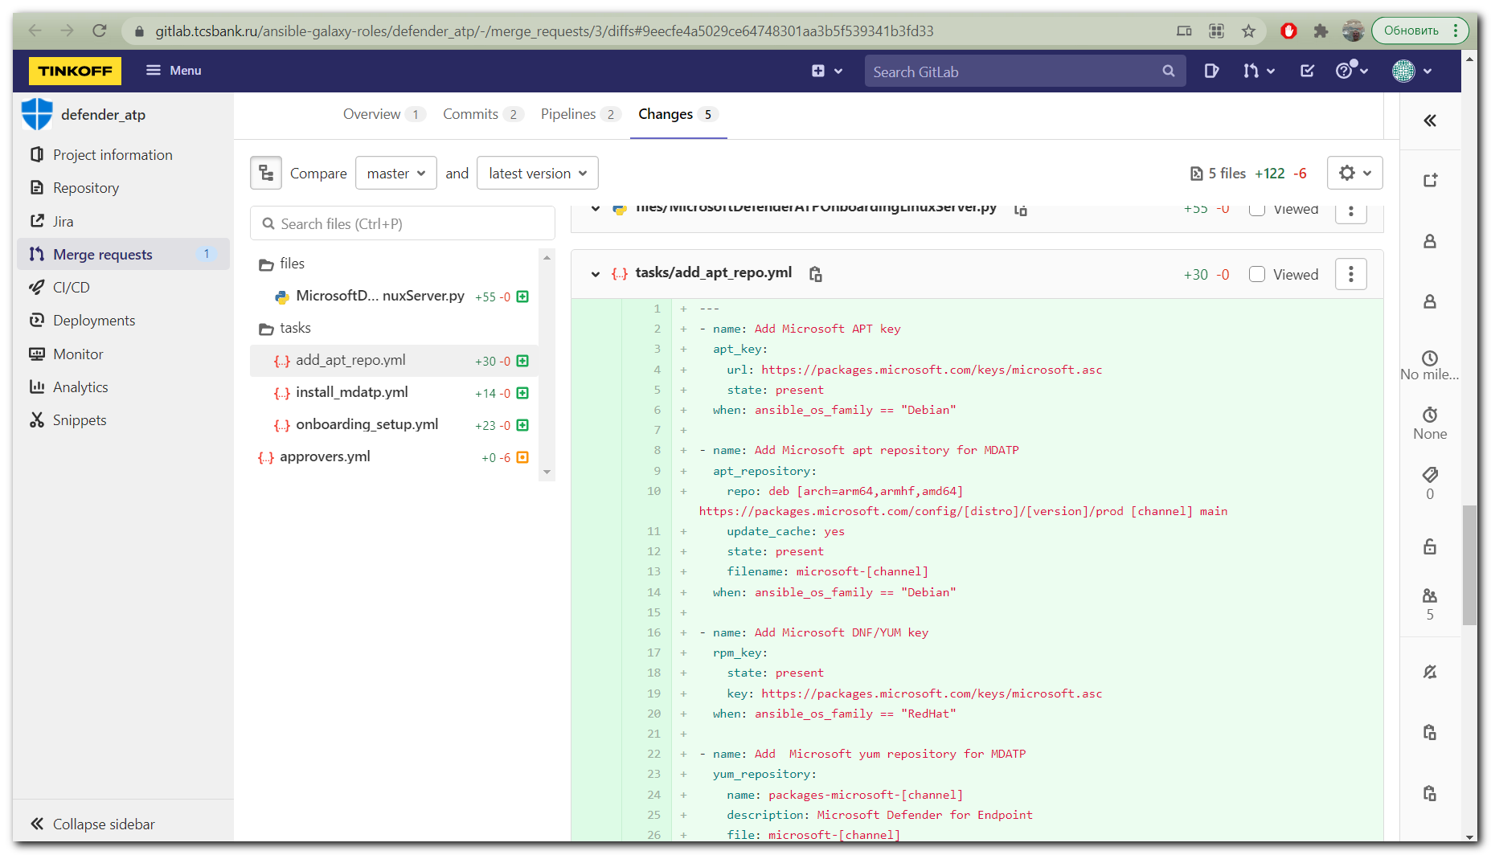

https://gitlab.tcsbank.ru/ansible-galaxy-roles/defender_atp/-/blob/master/tasks/add_apt_repo.yml

---
- name: Add Microsoft APT key
apt_key:
url: http://repo-linux.tcsbank.ru/repository/microsoft/keys/microsoft.asc
state: present
when: ansible_os_family == "Debian"

- name: Add Microsoft apt repository for MDATP
apt_repository:
repo: "deb [arch=arm64,armhf,amd64] http://repo-linux.tcsbank.ru/repository/microsoft/{{ansible_distribution | lower }}/{{ansible_distribution_version}}/prod {{channel}} main"
update_cache: yes
state: present
filename: "microsoft-{{channel}}"
when: ansible_os_family == "Debian"

- name: Add Microsoft DNF/YUM key
rpm_key:
state: present
key: http://repo-linux.tcsbank.ru/repository/microsoft/keys/microsoft.asc
when: ansible_os_family == "RedHat"

- name: Add Microsoft yum repository for MDATP
yum_repository:
name: "packages-microsoft-{{channel}}"
description: Microsoft Defender for Endpoint
file: "microsoft-{{channel}}"
baseurl: "http://repo-linux.tcsbank.ru/repository/microsoft/{{ansible_distribution | lower }}/{{ansible_distribution_version}}/{{channel}}/"
gpgcheck: yes
enabled: Yes
when: ansible_os_family == "RedHat"

Dec 17, 2021
https://help.ubuntu.com/community/Repositories/CommandLine
